Risk Assessment

Risk Assessment

Liability Risk Assessment & Control Recommendations
[Enter Event Name, Date & Time]
Task / Activity/Asset | The Risk | Risk Assessment |  | Risk Rating ( III ) | Control Measures | Person Responsible | Completion Date
 |  | Likelihood ( I ) | Consequence ( II )
List the individual tasks or activities.  For risk assessments on Council assets - list the Council asset involved. | Identify the range of potential Risks associated with each task/activity. What can happen? How can it happen? | Used as a qualitive description of  probability or frequency. | The outcome of an event expressed qualitively or quantitatively, being a loss, injury, disadvantage or  gain. | The likelihood and the Consequ ences of a Risk  occurring | Identify suitable control measures for each identified Risk taking into consideration the Risk Rating. | The person given the responsibility to implement and/or manage the Control Measures. | The date the intended Controls will be implemented and/or managed.

Electronic Version is the controlled version. Printed copies are considered uncontrolled. Before using a printed copy verify that it is the current version. Page 1 of 3

Document Name | Version Number | Date of Issue | Review Date
RISK – Risk Assessment | 1.0.0 | 2 July 2014 | July 2016

Liability Risk Assessment & Control Recommendations
[Enter Event Name, Date & Time]
Task / Activity/Asset | The Risk | Risk Assessment |  | Risk Rating | Control Measures | Person Responsible | Completion Date
 |  | Likelihood ( I ) | Consequence ( II ) | ( III )

Risk Assessment completed by: Date:

Electronic Version is the controlled version. Printed copies are considered uncontrolled. Before using a printed copy verify that it is the current version. Page 2 of 3
Risk Assessment Version 1.0.0

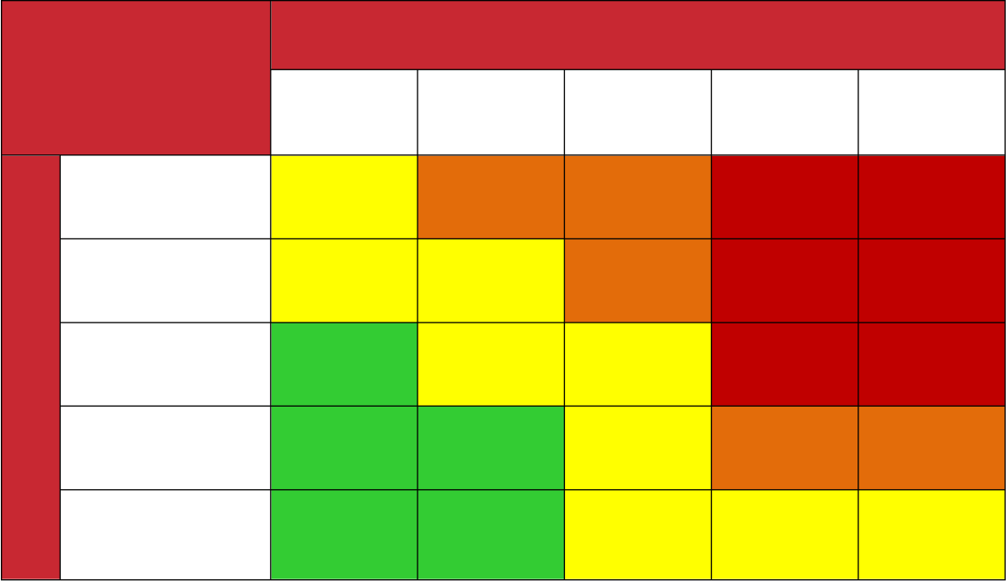
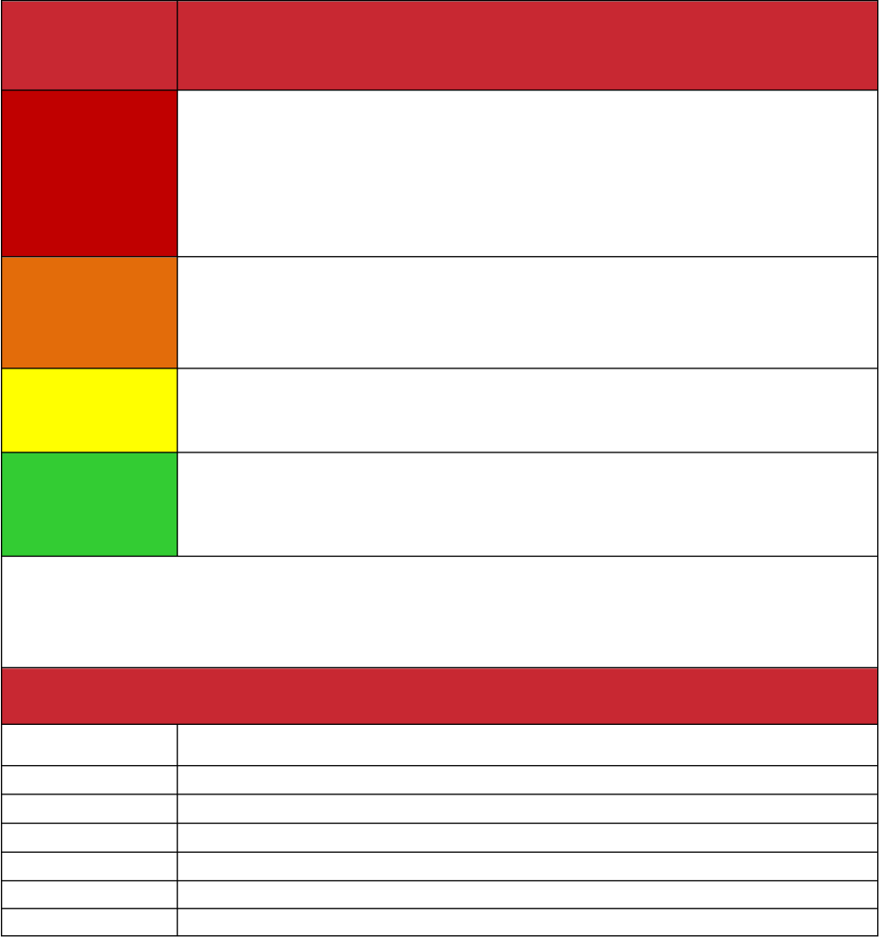
Risk Assessment Matrix |  |  | Consequences
 |  | Negligible No injuries or not requiring first aid | Minor  First aid needed | Moderate Medical treatment | Major  Serious injury | Severe Death or permanent disability.
 | Certain to occur Expected to occur in most circumstances | Medium 8 | High 16 | High 20 | Extreme | Extreme
 | Very Likely  Will probably occur in most circumstances | Medium 7 | Medium 12 | High | Extreme | Extreme
Likelihood
 | Possible  May occur occasionally | Low 5 | Medium 10 | Medium | Extreme | Extreme
 | Unlikely  Could happen at some time | Low 2 | Low 4 | Medium | High | High
 | Rare  May happen only in  exceptional circumstances | Low 1 | Low 3 | Medium | Medium | Medium

Risk Level | Recommended Actions
Extreme 23 - 25 | This rating level is not acceptable  Report immediately to Senior Management  Consider alternative activity unless controls implanted Develop specific Treatment /Action Plan for immediate action  Allocate actions and budget for implementation within 1 month Report to Senior Management on effectiveness of control
High 14 - 22 | Develop and implement a treatment /action plan for high risks Consider alternative activity unless controls implemented Allocate Action and budget to minimise risk, monitor  Report to Management on effectiveness of control
Medium 6 - 21 | Develop and implement action plan for medium risks  Allocate action/budget to minimise risk where control inadequate Consider additional controls
Low 1 - 5 | Accept and monitor low priority risks  Manage risks by routine procedures and monitor
Hierarchy of Controls
Priority | Control Method
1 | Eliminate the hazard
2 | Substitute safer equipment/processes
3 | Isolate the hazard
4 | Use engineering controls
5 | Use administrative controls
6 | Use personal protective equipment

Electronic Version is the controlled version. Printed copies are considered uncontrolled. Before using a printed copy verify that it is the current version. Page 3 of 3
Risk Assessment Version 1.0.0

